UNIT-III - TRANSDUCERS
Transducer:
A Transducer is an electronic device, which converts energy from one form to another form.
Examples:Microphones, Loudspeakers, thermometer, photo cells, LED's, position and pressure Sensors.
Classification of transducers:
Transducers are classified based the on structure, working, its output different Conversion and manipulating techniques etc.
1. Based on Source of Energy Requirement
a. Active Transducer. b. Passive Transducer
2. Based on physical phenomenon
a. primary transducer. b. Secondary transducer.
3. Based on its output
a. Analog Transducer. b. Digital Transducer.
4. Based on Transduction phenomenon
a. Electrical Transducer b. Inverse Transducer.
5. Based on Construction
a. Mechanical Transducer b. Electrical Transducer c. Optical Transducer
1. Based on source of energy requirements
Transducers are classified into two categorize.
- Active Transducer:
Transducers which do not use external power for the measurement of process variable is called Active Transducers. These transducers are self-generatingdevices, which operate Under the energy Conversion Principle.
Example: Thermocouples, Thermopiles, piezo-electric Crystal, Inductive transducer.
- Passive Transducer:
Passive transducers are those in which external power Supply is Required for the measurement
of process variable.
Example: Capacitive transducer, Resistive transducers Such as RTD, thermistor, Inductive Transducer Such as LVDT
2. Classification Based on physical phenomenon:
a. Primary transducer:
Primary transducer is the first stage in a measurement system, which changes its surroundings and produces an equivalent functional output which is detected by next stage or a second stage.
Examples: Bimetallic thermometer, liquid filled thermometer,manometer etc
- Secondary Transducer:
Secondary transducer is basically a Second stage in a measurement system, which defects the mechanical or physical change produced by primary sensing
Examples: PLVDT, piezo-electric crystal
3. Classification Based on its output:
a. Analog Transducer:
Analog Transducer provides output signal in Analog form (Voltage or Current)
Examples: potentiometer, LVDT, thermistor, RTD etc
- Digital Transducer:
Digital transducer provides output Signal in digital form. o/p is in the form of square pulsesExamples: Shaft encoder, pressure switch, digital tachometer, digital Resolver etc.

4. Classification Based Transduction phenomenon:
Electrical transducers:
Transducers whichconverts non-electrical signal into electrical signal are called Electrical Transducers.
Examples: potentiometer, LVDT, thermistor etc.
Inverse Transducer:
Transducer which is used to convert an electrical quantity into non-electrical quantity such as. displacement force temperature etc.
Examples: Analog Ammeter, piezo electric Crystal, Oscilloscope etc
5. Classification based construction:
Mechanical Transducer:
Mechanical transducer responds for the change inphysical quantity with a mechanical output such as force, displacement, pressure etc
Ex: Diaphragm, manometer etc.
Electrical Transducer:
Electrical transducers which converts non-electrical Signal into electricalsignal such as Voltage, Current etc
Ex: LVDT, Thermocouple etc. Optical Transducer:
Optical transducers:
Optical transducer which converts light in to electrical Signal are also called as opto-electric transducer (OR) photo-electric transducer.
Ex: Reflection, absorption, emission, radiation etc.

Selection of Transducers:
The following factors that influence the selection of a Transducer.
- Operating principle 2. Operating Range 3. Accuracy
- Sensitivity 5. Stability and Reliability 6. Usage and Ruggedness.
- Loading effect
Operating principle:
There are various transducers that use different operating principles like resistive, capacitive, inductive etc.
Operating range:
The operating Range of a transducer can be determined with its capabilities, and errors in the measurement
Accuracy:
The Accuracy of a transducer is the degree of closeness of the output obtained to the ideal value.
Sensitivity:
The sensitivity of a transducer is the output obtained per unit change in the input quantity. The Sensitivity "Should not be either very high or low that leads to errors
Stability and Reliability:
The stability of the transducer also describes storage life
Usage and Ruggedness
A transducer should be mechanically rugged depending the application where it is used.
Loading effect:
A transducer should have high input impedance and low output Impedance for minimum landing effects Transient Response and frequency: A Transfer Should have required time domain Specifications such as setting time, rise time.

RESISTIVE TOUCH SCREEN:
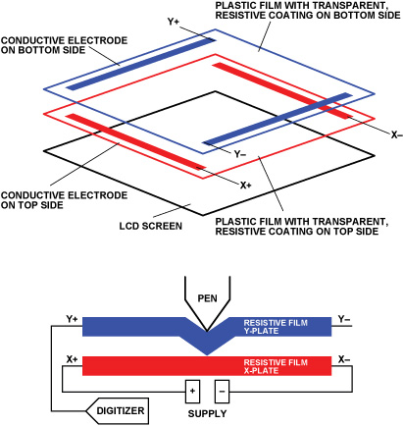
Resistive touch screen consists of a glass panel with film screen mounted on it. Both glass panel and film screen were covered with a thin metallic layer separated by a narrow gap. The two metallic layers make contact when user touches the screen, resulting in flow of charge carriers across the metallic layers. The point of contact is identified by the change in voltage.
Fig. Resistive Touch screen
MERITS:
- Can be activated with any object (stylus, fingers, and gloves)
- Low cost
- Low power consumption
- Resistant to contamination
DEMERITS:
- Low image clarity
- The outer screen can be damaged easily with sharp objects.
CAPACITIVE TOUCH SCREEN:
Capacitive touch screens are classified into two categories
1. Surface capacitive
2. Projected capacitive
Surface capacitive:
In surface capacitive touch screen, a transparent electrode (like ITO) is mounted on top surface of a glass plate or panel. A protective cover covers the transparent electrode. When touched the screen (electrode) reacts to the static electrical capacity of human body. As a result, some electrical charge transfer from screen to human body causing decrease in capacitance. The sensors placed at the corners of the screen detect the change in capacitance. These four sensors can exactly locate the point when the user touched the screen. These touch screens can only be activated by human skin or electrical stylus.



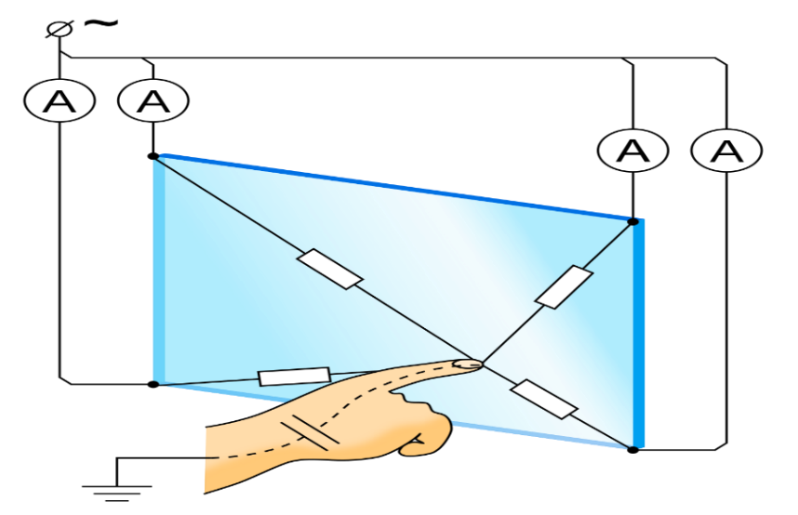
MERITS:
- Better image clarity
- Durable screen
- High scratch resistance
DEMERITS:
- Requires bare fingers to activate
- Sensitive to electromagnetic induction and radio frequency
PROJECTED CAPACITIVE:
Similar to surface capacitive but it can also be activated with surgical gloves or thin cotton gloves. Also, multi touch activation is possible in projected capacitive.
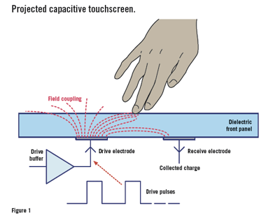
A projected capacitive touch screen consists of a glass sheet with embedded transparent electrode films and an integrated circuit chip (IC) these creates a three-dimensional electric field. When we touch the screen the ratio of electrical currents changes, by which we can identify touch point.
Fig. Projected capacitive touch screen
MERITS:
- High image clarity
- Resistant to scratch
- Multi touch
DEMERITS:
- Sensitive to EMI or RFI
LINEAR VARIABLE DIFFERENTIAL TRANSFORMER (LVDT)
LVDT is inductive transducer, which translates linear motion into electrical signals. The construction of LVDT is shown in figure.
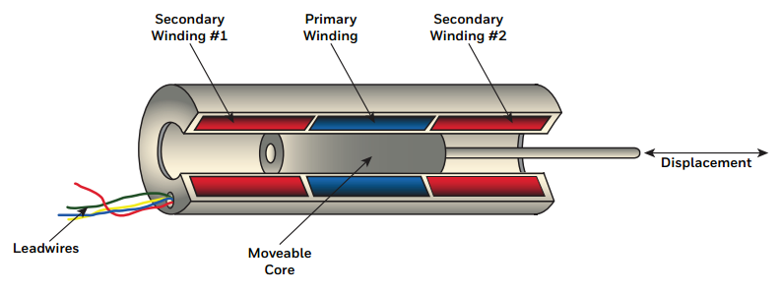
LVDT consists of long cylinder with a single primary winding “p” and two secondary windings S1 and S2 wound on it. The two secondary windings are identical in every manner and placed symmetrically on both sides of primary winding.
The primary winding is connected to an A.C source in the frequency range 50 to 20,000Hz. A linearly movable soft iron core is placed inside the cylindrical former. An arm is attached to the movable soft iron core. The Displacement to be measured is applied to the arm. Usually, the core is made of material with high permeability (Nickle iron). The core is longitudinally slotted to minimize the loses due to eddy currents. The above LVDT set up is shielded from external electrostatic and electromagnetic fields by using a stainless-steel housing.
An alternating magnetic field is produced, when an alternating current excites the primary winding. This alternating magnetic field induces alternating voltage in the secondary windings.
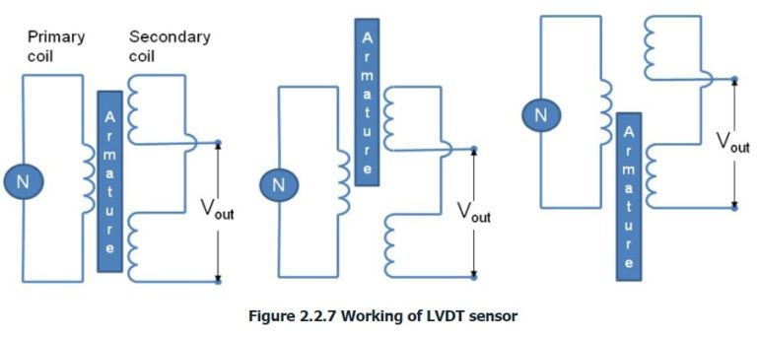
The two secondary windings connected in series opposition as shown in figure.
If the output voltage of S1 is E_{S1} and the output voltage of S2 is E_{S2}.
As S1 and S2 are connected in series opposition, the resultant differential output voltage is
E₀ =E_{S1}-E_{S2}
OPERATION:
In the null position (when no Displacement is applied to arm) the flux linked with both secondary windings is equal (E_{S1} = E_{S2}), so the output voltage E₀=0.
When the core moved to the left of the null position, more flux is linked to S1 than S2. So Es1 is greater than Es2 (E_{S1}>E_{S2}). Similarly, when there is a displacement to the right of null position, we get E_{S2}>E_{S1}(E_{S2} greater than E_{S1}). The amount of voltage change (change in E₀) in the secondary windings is proportional to the displacement of the core.
Hence, the output voltage is an indication of magnitude of displacement. We can also determine the direction of the displacement by observing whether the output voltage is increased or decreased.
MERITS:
- Good linearity (up to 5mm)
- Amplification is not necessary in most cases
- Continuous change in output voltage, hence good resolution
- Very high sensitivity
- Low power consumption and low hysteresis loss
DEMERITS:
- It has large threshold
- Proper shielding is required to avoid the effect of stray electromagnetic fields
- Noise due to A.C input
- Sensitivity decreases at high temperature
PIEZO –ELECTRIC TRANSDUCERS:
A Piezo-electric transducer is an electrical transducer which can convert any form of physical quantity into an electrical signal, which can be used for measurement. It is a device that uses the piezoelectric effect to calculate changes in acceleration, strain, temperature, or force by converting this energy in to an electrical charge transducer.
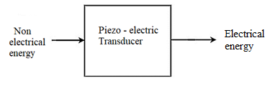
WORKING PRINCIPLE:
The piezoelectric transducers work on the principle of piezoelectric effect.
PIEZOELECTRIC EFFECT:
Piezoelectric effect was discovered by two French scientist’s brothers Jacques and Pierre Curie in 1880 in quartz crystal. This is due to asymmetry of atoms inside the crystal.
If mechanical force is applied across faces of certain crystals like quartz, equal and opposite electrical charges appear across its other faces. This is called a piezoelectric effect.
This effect is reversible. That is the converse of piezoelectric effect is also true.
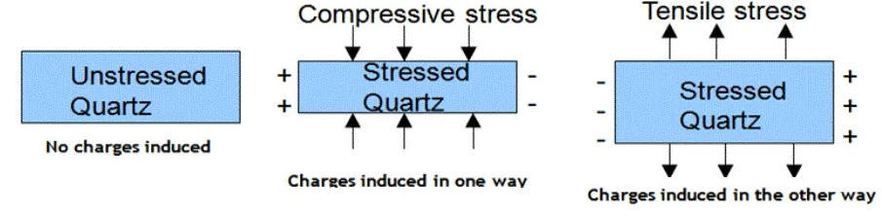
If potential difference is applied between surfaces of the crystal, then there will be change in the dimensions of the crystal and hence the crystal gets deformed. This is known as inverse piezoelectric effect.
PIEZOELECTRIC MATERIALS:
The materials exhibiting a significant and usefulpiezoelectric effect are called piezoelectric materials. These are divided into two groups.
1. Natural group: The natural group consists of quartz, Rochelle salt, Tourmaline etc
2. Synthetic group: Synthetic group consists of Ammonium Dihydrogen Phosphate (ADP), Lithium sulphate (LS) and Dipotassium Tarta (DKT).
- Piezoelectric materials should have frequency stability, high output values, insensitive to the external temperature and humidity conditions and should be flexible to be manufactured in to various shapes without disturbing their properties
- Quartz is the most stable material and artificially grown quartz is normally preferred as it is purer than the natural Quartz.
A simple piezoelectric crystal is shown in the figure. In a piezoelectric transducer, a piezoelectric crystal is sandwiched between the two electrodes.
The Piezoelectric effect is direction sensitive. A compressive force produces a voltage of one polarity while a tensile force produces a voltage of opposite polarity.
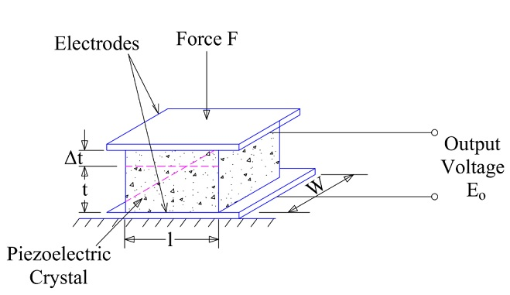
Let F be the mechanical force applied on the surfaces of the crystal. The magnitude and polarity of the induced surface charges are proportional to the magnitude and direction of the applied force F.
Charge Q = d F (1)
Where charge sensitivity of the crystal. It is constant for a given crystal. Its unit is coulomb/ newton.
This charge appears as voltage across the electrodes and is given by
V₀ = Q/C (2)
The capacitance of the Piezoelectric crystal between the two electrodes is
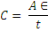
Where A = Area of the Piezoelectric crystal
t = thickness of the Piezoelectric crystal
є = Absolute permittivity of the crystal
From eq(2) (3)
From eqs (1) and (3)
In above expression, A, t, d, and є are constants for a given piezoelectric transducer. This means, the applied force F is directly proportional to the output voltage across the electrodes.
Therefore, output voltage

Where is called voltage sensitivity of the crystal. It is constant for the given crystal. It unit is V-m/N.
Equivalent circuit of piezo-electric circuit is shown in figure.
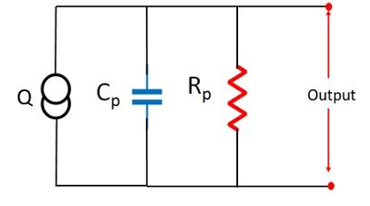
Advantages:
- These are active transducers. It means that they do not require external power for working and are therefore self-generating.
High frequency response:
- High frequency response of these transducers makes a good choice for various applications.
- The Piezo-electric transducers are small in size and have rugged construction. So they are easy to handle and utilize due their small dimensions.
Limitations:
- High impendence:The piezo- electric crystals have high impedance.
- Forming into shape: It is very difficult to give the desired shape to the crystals with sufficient strength.
- Temperature and environmental conditions can influence the behavior of the transducers.
Applications of Piezo-electric transducers
- As piezo-electric materials cannot, measure static values these are primarily used for measuring surface roughness, in accelerometers and as a vibration pick up.
- They are used in seismographs to measure vibrations in rockets.
- They are used in strain gauges to measure force, stress, vibrations etc.
- These are used in automotive industries to measure detonations in engines.
- These are used in ultrasonic imaging in medical applications.
- These are used in inkjet printers.
- These are used in smart phone screens.
- These are used in electric lighters in kitchens.
- They are used for studying high speed for shock waves and blast waves.
Photo electric transducers
Definition: The photo electric transducers convert the light energy into electrical energy. It is made of semiconductor material. The photo electric transducer uses a photo sensitive element, which ejects the electrons when the beam of light absorbs through it.
The bellow figure shows the semiconductor material.
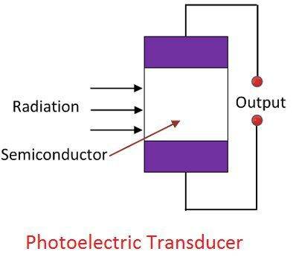
The photo electric transducers absorb the radiation of light which falls on their semiconductor material. The mobility of electrons produces one of the three effects.
- The resistance of the material changes
- The output current of the semiconductor changes
- The output voltage of the semiconductor changes.
Classification of photo electric transducers
The photo electric transducers are classified into the following ways. They are
- Photo emissive transducers
- Photo conductive transducers
- Photo voltaic transducers
Photo emissive transducer:
The photo emissive transducer works on the principle of photo electric effect.
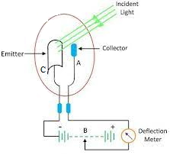
- It consists of a cathode C and anode A mounted in a vacuum tube made of glass.
- The cathode consists of a curved metal plates made of photo sensitive material such as cesium or Oxidised silver.
- The anode is made of nickel or platinum. It is in the form of a thin wire facing to the cathode.
- When the light of suitable frequency falls on the cathode, photo electrons are emitted and flow towards the anode.
- The anode it kept at the positive potential. Thus the photo electric current starts flowing through the circuit. The magnitude of the current is directly proportional to the intensity of the incident light.
Photoconductive Cell
The photoconductive cell converts the light energy into an electric current. It works on the principle of photo conductive effect. When light falls on a semiconductor material, then resistance will be decrease. It uses the semiconductor material like cadmium selenide, Ge, Se, as a photo sensing element.When the beam of light falls on the semiconductor material, their conductivity
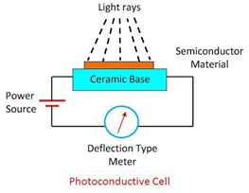
increases and the material works like a closed switch. The current starts flowing into the material and deflects the pointer of the meter.
Photo-voltaic cell:
The photovoltaic cell is the type of active transducer. It is also known as solar cell. It converts electromagnetic radiation into an electrical signal. It works on the principle of photo voltaic effect i.e when light strikes a junction of certain dissimilar metals, a voltage is generated.The silicon, Ge, and selenium are used as a semiconductor material.
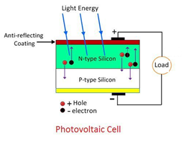
When the semiconductor material is exposed to light, the free electrons of the material starts moving. The movements of electrons develop the current in the cell, and the current is known as the photoelectric current.
Applications of photo transducers:
- These are used in automatic lights to activate whenever it gets dark, and the activation / deactivation of street lights mainly depends on the day whether it is day or night.
- These are used as timers in a running race to calculate the runner’s speed.
- Photo cells are used to count the vehicles on the road.
- These are used instead of photo voltaic cells and variable resisters.
- These are used in lux meters to decide the light intensity.
- These are used as switches as wel as sensors.

